**Encoders and Decoders**

1. Design & Explain working of:
2. Decimal to BCD Encoder

Ans: **Encoder:** An Encoder is a combinational circuit that performs the reverse operation of a Decoder. It has a maximum of 2^n input lines and ‘n’ output lines, hence it encodes the information from 2^n inputs into an n-bit code. It will produce a binary code equivalent to the input, which is active High. Therefore, the encoder encodes 2^n input lines with ‘n’ bits.

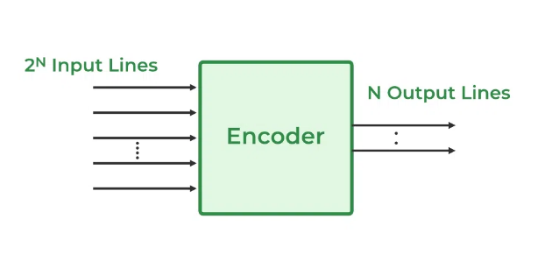

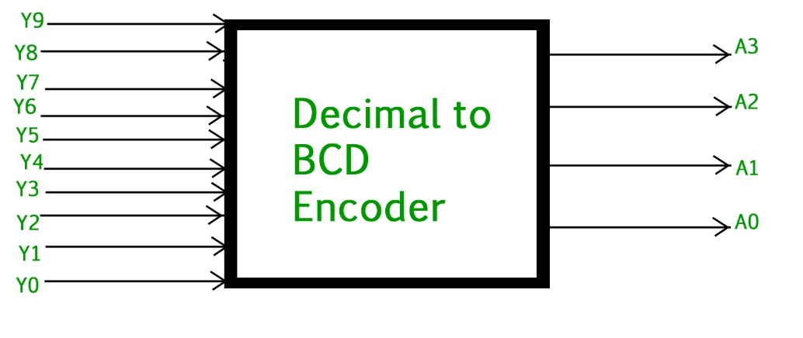

The truth table for decimal to[BCD encoder](https://www.geeksforgeeks.org/bcd-or-binary-coded-decimal/) is as follows.

| **INPUTS** | | | | | | | | | | **OUTPUTS** | | | |
| --- | --- | --- | --- | --- | --- | --- | --- | --- | --- | --- | --- | --- | --- |
| **Y9** | **Y8** | **Y7** | **Y6** | **Y5** | **Y4** | **Y3** | **Y2** | **Y1** | **Y0** | **A3** | **A2** | **A1** | **A0** |
| 0 | 0 | 0 | 0 | 0 | 0 | 0 | 0 | 0 | 1 | 0 | 0 | 0 | 0 |
| 0 | 0 | 0 | 0 | 0 | 0 | 0 | 0 | 1 | 0 | 0 | 0 | 0 | 1 |
| 0 | 0 | 0 | 0 | 0 | 0 | 0 | 1 | 0 | 0 | 0 | 0 | 1 | 0 |
| 0 | 0 | 0 | 0 | 0 | 0 | 1 | 0 | 0 | 0 | 0 | 0 | 1 | 1 |
| 0 | 0 | 0 | 0 | 0 | 1 | 0 | 0 | 0 | 0 | 0 | 1 | 0 | 0 |
| 0 | 0 | 0 | 0 | 1 | 0 | 0 | 0 | 0 | 0 | 0 | 1 | 0 | 1 |
| 0 | 0 | 0 | 1 | 0 | 0 | 0 | 0 | 0 | 0 | 0 | 1 | 1 | 0 |
| 0 | 0 | 1 | 0 | 0 | 0 | 0 | 0 | 0 | 0 | 0 | 1 | 1 | 1 |
| 0 | 1 | 0 | 0 | 0 | 0 | 0 | 0 | 0 | 0 | 1 | 0 | 0 | 0 |
| 1 | 0 | 0 | 0 | 0 | 0 | 0 | 0 | 0 | 0 | 1 | 0 | 0 | 1 |

Expression:

A3 = Y9 + Y8  
 A2 = Y7 + Y6 + Y5 +Y4  
 A1 = Y7 + Y6 + Y3 +Y2  
 A0 = Y9 + Y7 +Y5 +Y3 + Y1

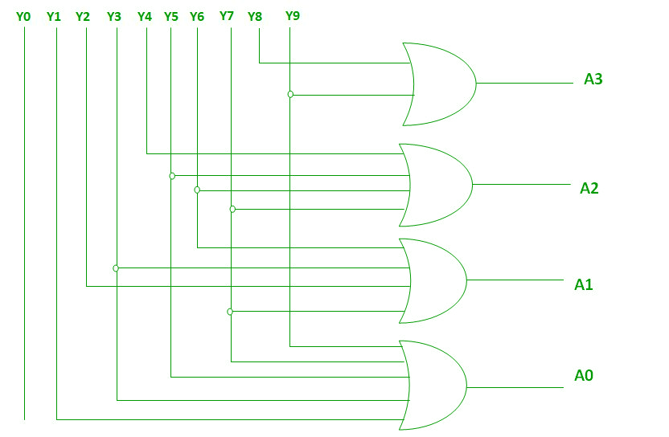Implementation using OR gates

1. Octal to Binary encoder using OR gates

The 8 to 3 Encoder or octal to Binary encoder consists of **8 inputs**: Y7 to Y0 and **3 outputs**: A2, A1 & A0.

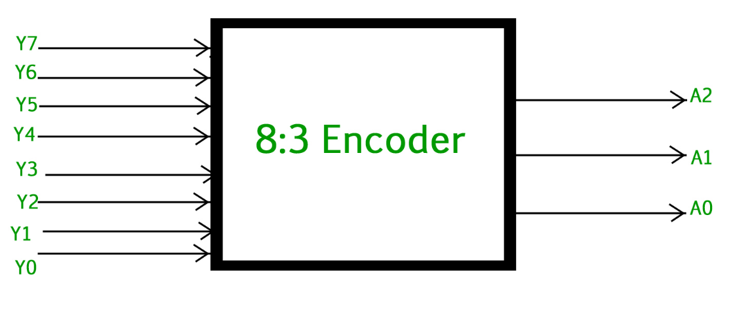

The truth table for the 8 to 3 encoder is as follows.

|  |  |  |  |  |  |  |  |  |  |  |  |
| --- | --- | --- | --- | --- | --- | --- | --- | --- | --- | --- | --- |
| INPUTS | | | | | | OUTPUTS | | | | | |
| Y7 | Y6 | Y5 | Y4 | Y3 | Y2 | | Y1 | Y0 | A2 | A1 | A0 |
| 0 | 0 | 0 | 0 | 0 | 0 | | 0 | 1 | 0 | 0 | 0 |
| 0 | 0 | 0 | 0 | 0 | 0 | | 1 | 0 | 0 | 0 | 1 |
| 0 | 0 | 0 | 0 | 0 | 1 | | 0 | 0 | 0 | 1 | 0 |
| 0 | 0 | 0 | 0 | 1 | 0 | | 0 | 0 | 0 | 1 | 1 |
| 0 | 0 | 0 | 1 | 0 | 0 | | 0 | 0 | 1 | 0 | 0 |
| 0 | 0 | 1 | 0 | 0 | 0 | | 0 | 0 | 1 | 0 | 1 |
| 0 | 1 | 0 | 0 | 0 | 0 | | 0 | 0 | 1 | 1 | 0 |
| 1 | 0 | 0 | 0 | 0 | 0 | | 0 | 0 | 1 | 1 | 1 |

Logical expression for A2, A1, and A0.

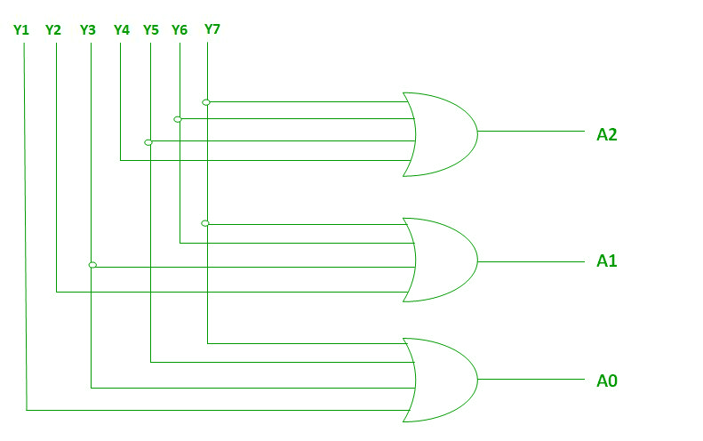A2 = Y7 + Y6 + Y5 + Y4  
A1 = Y7 + Y6 + Y3 + Y2  
A0 = Y7 + Y5 + Y3 + Y1

1. 3:8 Decoder

**Decoder: A decoder is a digital circuit that takes a small number of inputs and translates (or decodes) them into a larger number of unique outputs.**

It is also called a binary-to-octal decoder since the inputs represent 3-bit binary numbers and the outputs represent the eight digits in the octal number system.

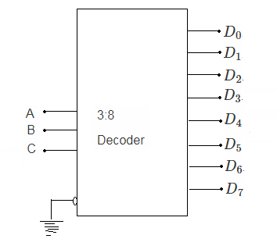

Truth table of 3 to 8 decoder:

Inputs Outputs

|  |  |  |  |  |  |  |  |  |  |  |
| --- | --- | --- | --- | --- | --- | --- | --- | --- | --- | --- |
| A | B | C | D0 | D1 | D2 | D3 | D4 | D5 | D6 | D7 |
| 0 | 0 | 0 | 1 | 0 | 0 | 0 | 0 | 0 | 0 | 0 |
| 0 | 0 | 1 | 0 | 1 | 0 | 0 | 0 | 0 | 0 | 0 |
| 0 | 1 | 0 | 0 | 0 | 1 | 0 | 0 | 0 | 0 | 0 |
| 0 | 1 | 1 | 0 | 0 | 0 | 1 | 0 | 0 | 0 | 0 |
| 1 | 0 | 0 | 0 | 0 | 0 | 0 | 1 | 0 | 0 | 0 |
| 1 | 0 | 1 | 0 | 0 | 0 | 0 | 0 | 1 | 0 | 0 |
| 1 | 1 | 0 | 0 | 0 | 0 | 0 | 0 | 0 | 1 | 0 |
| 1 | 1 | 1 | 0 | 0 | 0 | 0 | 0 | 0 | 0 | 1 |

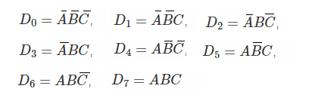

1. 4:2 Priority Encoder

A 4 to 2 priority encoder has **4 inputs**: Y3, Y2, Y1 & Y0, and **2 outputs**: A1 & A0.

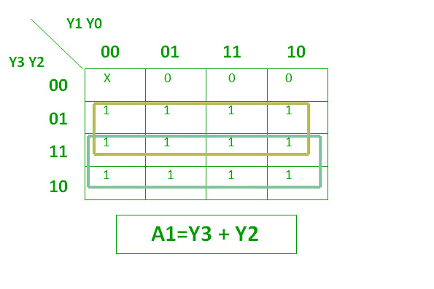

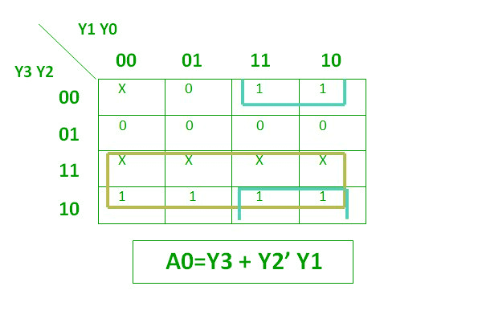

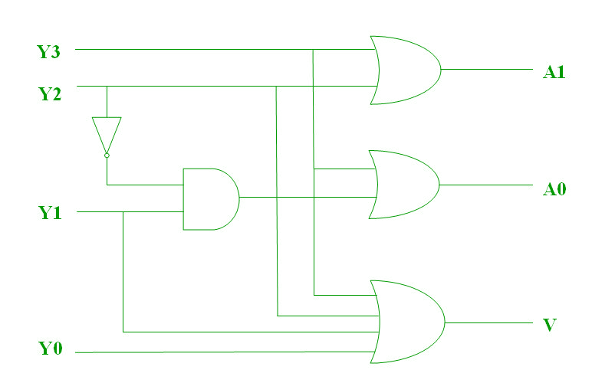

1. Explain difference between:
2. Encoder & Decoder

| **Encoder** | **Decoder** |
| --- | --- |
| Encoder circuit basically converts the applied information signal into a coded digital bit stream. | Decoder performs reverse operation and recovers the original information signal from the coded bits. |
| In case of encoder, the applied signal is the active signal input. | Decoder accepts coded binary data as its input. |
| The number of inputs accepted by an encoder is 2n. | The number of input accepted by decoder is only n inputs. |
| The output lines for an[encoder](https://www.geeksforgeeks.org/encoder-in-digital-logic/) is n. | The output lines of an decoder is 2n. |
| The encoder generates coded data bits as its output. | The decoder generates an active output signal in response to the coded data bits. |
| The operation performed is simple. | The operation performed is complex. |
| The encoder circuit is installed at the transmitting end. | The decoder circuit is installed at the receiving side. |
| OR gate is the basic logic element used in it. | AND gate along with NOT gate is the basic logic element used in it. |
| It is used in E-mail, video encoders etc. | It is used in Microprocessors, memory chips etc. |

1. Encoder & Priority Encoder

| **Feature** | **Encoder** | **Priority Encoder** |
| --- | --- | --- |
| **Function** | Converts one active input to a binary code on the output. | Converts active input(s) to binary code with priority handling. |
| **Handling Multiple Inputs** | Assumes only one input is active at a time. Multiple active inputs can cause undefined output. | Handles multiple active inputs by encoding the highest-priority active input. |
| **Priority** | No priority among inputs. | Inputs have priority levels; highest-priority input is encoded if multiple are active. |
| **Output** | Binary code based on active input. If multiple inputs are active, output may be incorrect or undefined. | Binary code based on the highest-priority active input. |
| **Application Examples** | Keypad encoding, basic binary coding systems. | Interrupt handling in microprocessors, systems needing prioritized signals. |

1. Explain applications of:
2. Priority Encoder

* It is used to reduce the no. of wires and connections required for [electronic circuit](https://www.elprocus.com/simple-electronic-circuits-for-beginners/) designing that have multiple input lines. Example keypads and keyboards.
* Used in controlling the position in the ship’s navigation and [robotics](https://www.elprocus.com/embedded-robotics-real-time-robotic-applications-on-embedded-systems/) arm position.
* Used in the detection of highest priority input in various applications of microprocessor interrupt controllers.
* Used to protect the entire network from hackers by transmitting the binary code over the network.
* Used to encode the analog to digital converter’s output.
* Used in synchronization of the speed of motors in industries.
* Used robotic vehicles
* Used in applications of home[automation systems](https://www.elprocus.com/home-automation-system-applications/) with RF
* Used in hospitals for health monitoring systems

1. Decoder

**1.Memory tending to:**In computerized frameworks, paired decoders are generally used to choose a particular memory area from a variety of memory areas. The location inputs are applied to the double decoder, and the comparing memory area is chosen.

**2.Control circuits:**Parallel decoders are utilized in charge circuits to produce control signals for various tasks. For instance, in a microchip, a double decoder is utilized to translate the guidance opcode and produce control signals for the comparing activity.

**3.Display drivers: I**n computerized frameworks that utilization show gadgets, for example, Drove shows, parallel decoders are utilized to drive the presentation. The double data sources are applied to the decoder, and the relating Drove is enlightened.

**4.Address unraveling:**Parallel decoders are utilized in address disentangling circuits to create the chip select sign for a particular memory or fringegadget.

**5.Digital correspondence:**Twofold decoders are utilized in advanced correspondence frameworks to unravel the computerized information got over the correspondence channel.

**6.Error rectification:**Double decoders are utilized in mistake amendment circuits to recognize and address blunders in computerized information.

1. What are the basic functions of:
   1. Digital Encoder

**Input Conversion**: An encoder takes multiple input signals (like buttons or switches) and converts them into a smaller number of outputs, usually in binary format.

**Outputs Represent Inputs**: Each active input corresponds to a specific binary code on the output. For example, if you press a button, the encoder tells the system which button was pressed by sending a code.

**Handling Multiple Inputs**: If only one input is active at a time, it works well. But some advanced encoders (called priority encoders) can tell you which input is most important if more than one is pressed.

**Reducing Data Lines**: By using an encoder, you can use fewer wires to represent many inputs. This is helpful in saving space and simplifying connections in circuits.

**Common Uses**: Encoders are often found in keyboards, remote controls, and any device where you need to turn multiple options into simple codes for processing.

* 1. Digital Decoder

**Input Conversion**: A decoder takes binary input signals and converts them into multiple output lines. The number of output lines is usually greater than the number of input lines.

**Activating Outputs**: Based on the binary value of the input, the decoder activates one specific output line. For example, if you input a binary number, only one output will be "on" (high), while all other outputs will be "off" (low).

**One Hot Output**: The decoder ensures that for every input combination, only one output is activated. This is often referred to as "one-hot" output.

**Address Decoding**: In computer systems, decoders are used to select specific memory addresses. When a particular address is given as input, the decoder activates the corresponding memory chip or location.

**Data Routing**: Decoders can be used in communication systems to route data to the correct destination based on the input signals.

**Common Uses**: Digital decoders are found in various applications, such as driving displays (like seven-segment displays), memory address decoding in computers, and control signal generation in electronic devices.